**COMPONENT DIAGRAM & DEPLOYMENT DIAGRAM**

**HU22CSEN0100999**

**ESHWAR DESHMUKH CHAVAN**

**Component Diagram**

* **Definition:**  
  Shows how a system is divided into modular parts (components) and how these parts interact.
* **Notations:**
  + **Components:** Rectangles (often with a «component» icon) that represent modules (e.g., UI, business logic, database).
  + **Interfaces:** Small circles (lollipop notation) that show provided or required services.
  + **Dependencies:** Dashed arrows that indicate how components depend on one another.

**ATM Component Diagram:**

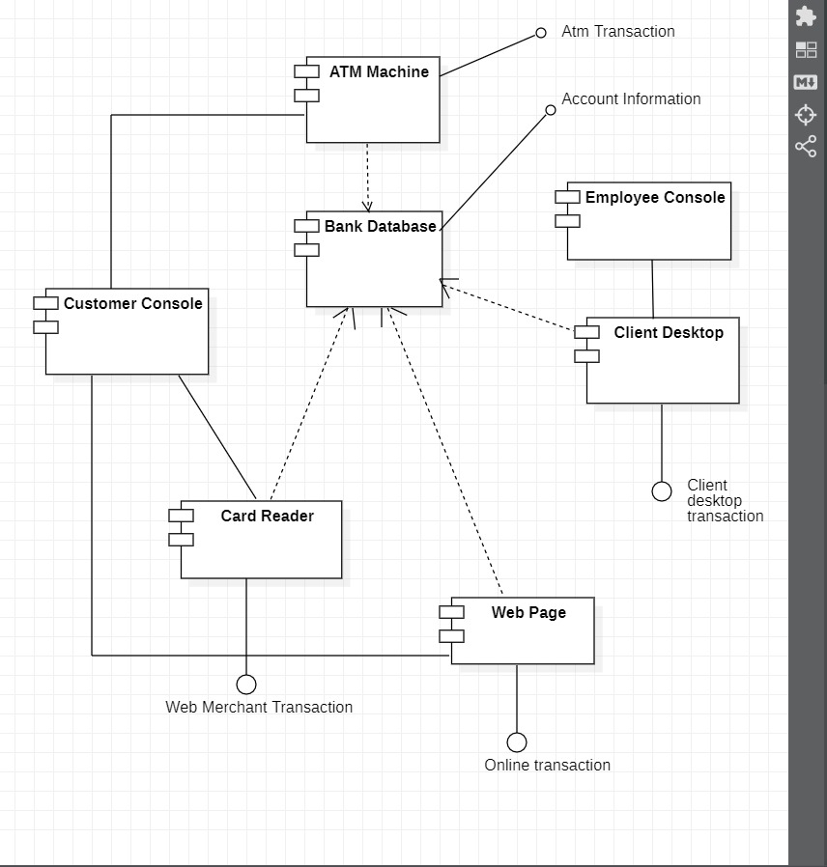

**Diagram Overview**

* A UML Component Diagram representing a banking/ATM system.
* Boxes with small tabs are components; lines indicate relationships/data flows.

**Key Components**

* **ATM Machine**: Handles withdrawals, deposits, and balance inquiries.
* **Bank Database**: Central repository for account information and transaction data.
* **Customer Console**: Interface for customers (could be an in-branch kiosk or portal).
* **Card Reader**: Reads card data for ATM or web-based transactions.
* **Web Page**: Supports online banking (transfers, bill payments).
* **Employee Console & Client Desktop**: Used by staff or specialized clients for desktop-based tasks.

**Notable Interactions**

* **ATM Machine ↔ Bank Database**: Processes ATM transactions, updates accounts.
* **Customer Console & Card Reader**: Authenticates user card details.
* **Web Page ↔ Bank Database**: Manages online transactions and account services.
* **Employee Console & Client Desktop ↔ Bank Database**: Handles administrative or specialized transactions.

**Transactions**

* **ATM Transaction**: Cash withdrawals, deposits, account checks.
* **Web Merchant Transaction**: Card-based payment processing through web.
* **Online Transaction**: Internet-based operations via the Web Page.
* **Client Desktop Transaction**: Specialized tool for staff/clients connecting to the database.

**University Component Diagram:**

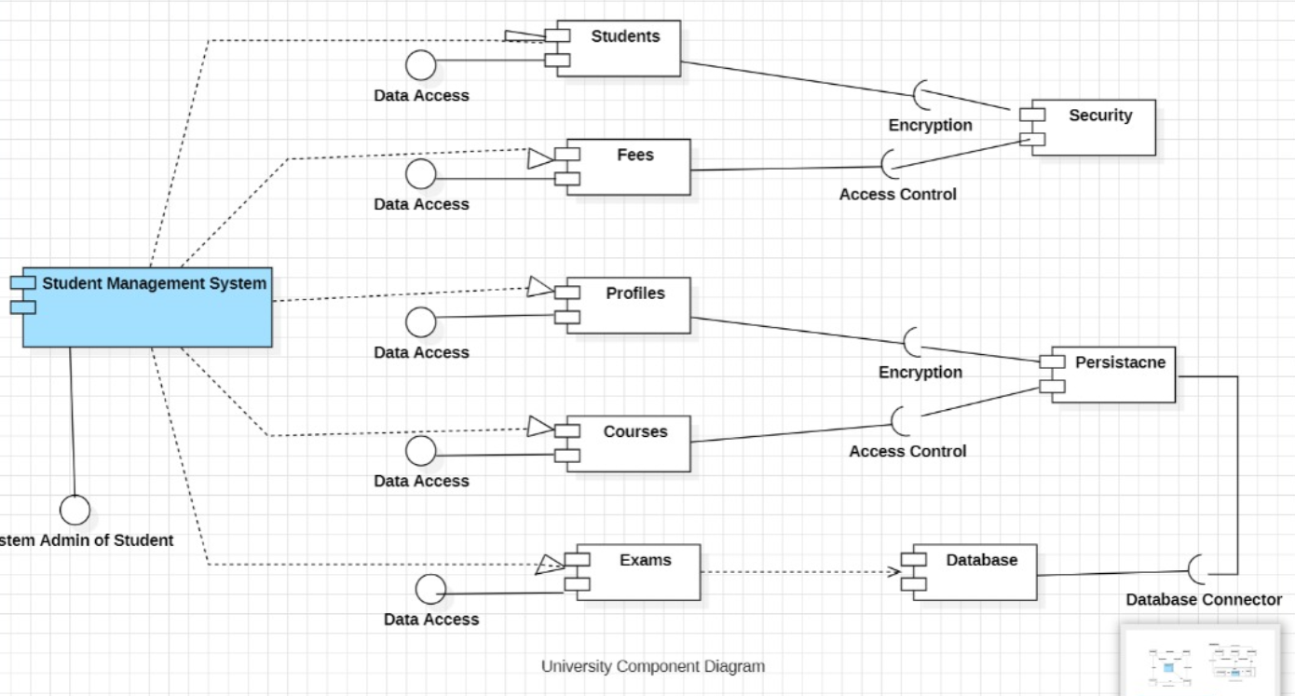

**Diagram Overview**

* A UML Component Diagram for a university’s Student Management System.
* Boxes with small tabs represent modules; lines show data access or interactions.

**Key Components**

* **Student Management System**: Central module overseeing student-related functions.
* **Students**: Manages student records and personal information.
* **Fees**: Handles financial transactions and billing details.
* **Profiles**: Stores and manages user profiles (e.g., staff, faculty, students).
* **Courses**: Maintains course offerings, schedules, and enrollment data.
* **Exams**: Manages exam scheduling, grading, and results.
* **Database & Database Connector**: Stores and retrieves persistent data; acts as the back-end.

**Notable Interactions**

* **Data Access**: Each module (Students, Fees, Profiles, Courses, Exams) connects to the main system for reading/writing data.
* **Encryption & Security**: Certain modules (e.g., Courses, Profiles) apply encryption or access control to protect data.
* **Persistence**: The main system or modules communicate with the Database via a connector for storing information.
* **System Admin of Student**: May have direct administrative privileges for managing student data.

**Deployment Diagram**

* **What It Shows:**  
  The image outlines the physical distribution of the university system’s components.
* **Key Elements:**
  + **Nodes:** 3D boxes representing physical devices such as Web Servers, Application Servers, and Database Servers.
  + **Artifacts:** The deployed software components (like the student portal or course management application) shown as rectangles on the nodes.
  + **Communication Paths:** Lines that indicate how the servers and devices connect and communicate over a network.

**ATM Deployment Diagram:**

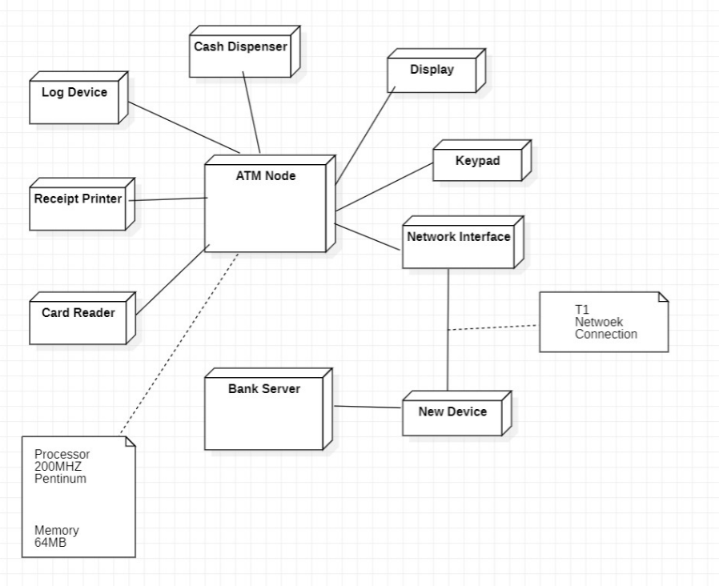 **Diagram Overview**

* A UML **Deployment Diagram** illustrating the physical setup of an ATM system.
* The central **ATM Node** is shown with various connected hardware components and network connections.

**Key Hardware Components**

* **ATM Node**: Main computer hardware running the ATM software.
  + Processor: 200 MHz Pentium
  + Memory: 64 MB
* **Cash Dispenser**: Dispenses cash to the user.
* **Display**: Screen showing prompts and transaction details.
* **Keypad**: Allows the user to enter PINs and amounts.
* **Card Reader**: Reads data from the user’s ATM card.
* **Receipt Printer**: Prints transaction receipts.
* **Log Device**: Possibly tracks system logs or error events.
* **Network Interface**: Connects the ATM to external networks.
* **T1 Network Connection**: High-speed link to the bank’s systems.
* **Bank Server**: Remote server handling transaction processing.
* **New Device**: An additional component (unspecified in detail).

**Connections**

* Each peripheral (cash dispenser, display, keypad, etc.) is attached to the **ATM Node**.
* The **Network Interface** on the ATM Node links to the **T1 Network Connection**, which connects to the **Bank Server** for transaction validation and account updates.

**University Deployment Diagram:** 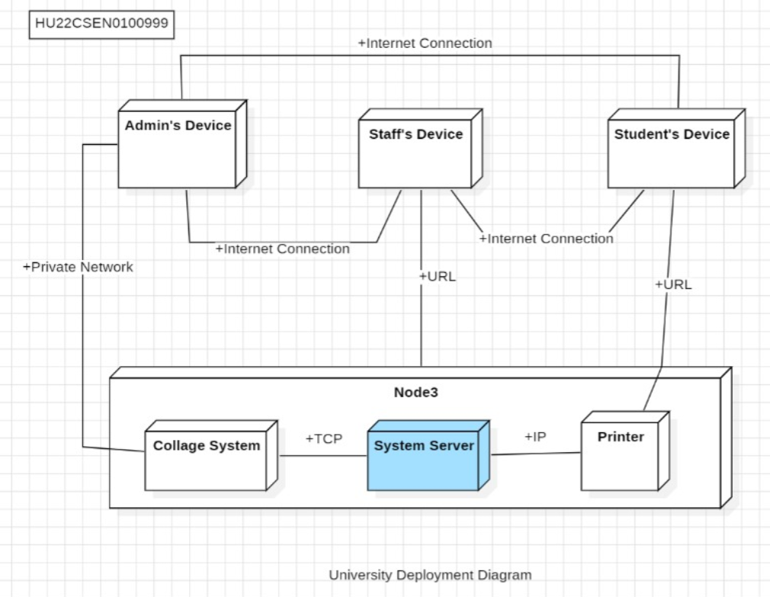

**Diagram Overview**

* A UML **Deployment Diagram** showing how the university’s systems are physically set up.
* **Node3** hosts core applications, while different user devices connect via internet or private networks.

**Key Hardware/Software**

* **Admin’s Device, Staff’s Device, Student’s Device**: Each user’s machine, connected via the internet or a private network.
* **Node3**: A server node hosting:
  + **Collage System**: A university software application (possibly for course management).
  + **System Server**: The main server handling requests and data processing.
  + **Printer**: A network printer accessible to the system.

**Connections**

* **Internet Connection**: Allows remote access for Admin, Staff, and Students.
* **Private Network**: May be used for internal or more secure communication.
* **URLs, TCP/IP**: Protocols and addresses for data transfer between the server and user devices.